📘 Project Documentation

Project Title:

**📊Metro Mart Retail Analytics – Business Insights Dashboard**

**Submitted By:**

Vedanth Reddy S N

**Domain:**

Data Analytics

**Tools & Technologies Used:**

SQL (MySQL Workbench)

Excel (Pivot Tables, Charts, Dashboard)

**Date:**

August 2025

**Table of Contents**

1. Project Overview
2. Objectives
3. Business Questions
4. Dataset Description
5. Tools & Technologies
6. Methodology / Approach
7. Insights & Findings
8. Dashboard Preview
9. Challenges & Solutions
10. Conclusion
11. Future Improvements
12. References

**Project Overview**

Retail companies generate huge amounts of data every day through sales, customers, and product transactions. Without proper analysis, this raw data has little business value.

This project aims to analyze retail sales data and design a Business Insights Dashboard that provides clear, actionable insights. The dashboard highlights key performance metrics such as revenue trends, customer behavior, product performance & stores analysis

*Goal:* Enable business leaders to make data-driven decisions and improve profitability.

**Objectives**

* Analyze sales trends across different time periods.
* Identify top-performing products and categories.
* Recognize high-value customers and their contribution.
* Detect areas of loss and suggest improvements.
* Create an interactive dashboard to summarize insights.

**Business Questions**

* **What is the total Gross Revenue?**

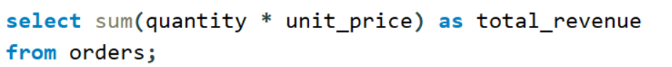

* **Display Regional Sales Performance**

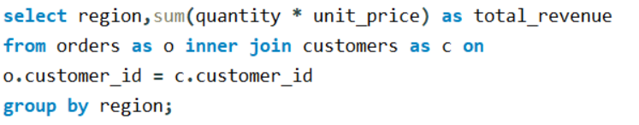

* **How much Sales Contributed by Category?**

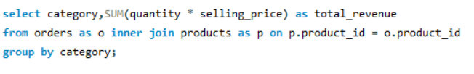

* **What is the total Revenue Distribution by Month?**

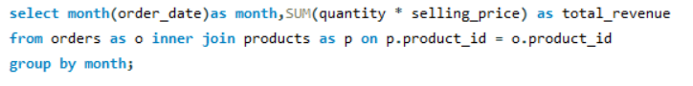

* **What is the average order value?**

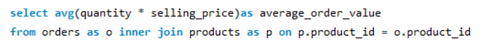

* **Display Customer Age Segment Revenue**

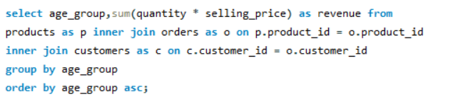

* **Fetch the Returns Overview**

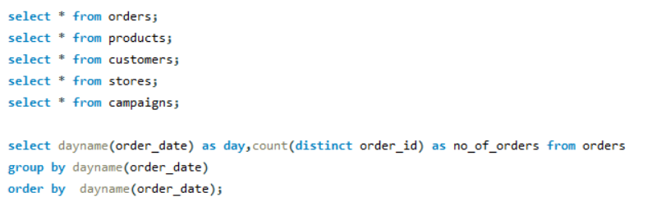

* **Display Day-wise Performance**

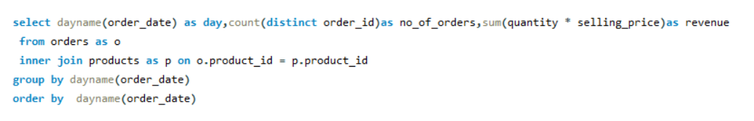

* **Which is the Top Performer by Sales?**

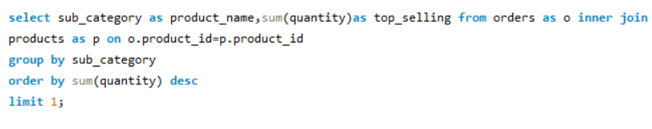

* **Which is the Low-Performing Product?**

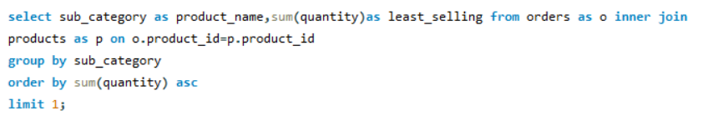

* **Display Weekly Revenue Trends?**

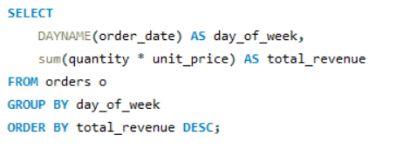

* **Fetch Seasonal and Weekly Sales Analysis**

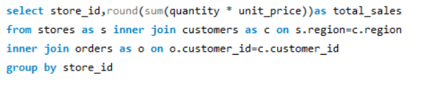

* **What is the Revenue by Store Location?**

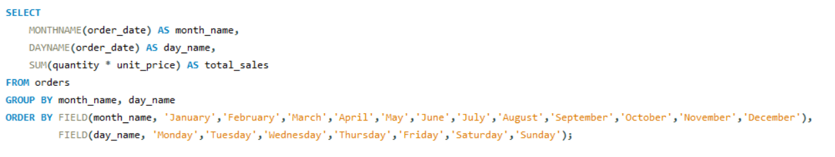

**Dataset Description**

* Source: Sample Superstore Dataset (Retail Sales)
* Size: ~500 rows, 8+ columns

**Key Fields:**

* Order ID – Unique order identifier
* Order Date – Date of transaction
* Customer Name – Customer details
* Product Category – Product type (Furniture, Technology, Office Supplies)
* Sellin price – Sales amount
* Profit – Profit generated
* Age group - customer info
* Region – Geographic sales region

**Tools & Technologies**

* SQL (MySQL Workbench): Data extraction & analysis
* Excel: Pivot Tables, Advanced Formulas, Charts, Dashboard design

**Methodology / Approach**

* Derived new columns (e.g., Month, Year, Profit Margin %)
* _Data Analysis_
* SQL queries for KPIs (Top customers, monthly sales, profit trends)
* Excel Pivot Tables for quick aggregations
* Charting for visual insights
* _Dashboard Creation_
* Designed an interactive Excel dashboard
* Added slicers for Year, Region, and Category
* Created KPIs: Total Sales, Total Profit, Top Customers, Best Category

**Insights & Findings**

* Revenue Performance:

The West region dominates sales, generating 40% higher revenue than the North.

Electronics category drives the highest revenue, reflecting strong customer demand.

* Customer Behavior:

The 50+ age group shows strong purchasing power, while 18–25 and 26–35 segments also significantly contribute to revenue.

Average Order Value (AOV) is $29.21, indicating moderate ticket size per order.

* Sales Trends:

January & February recorded peak revenue months, while mid-year (July–August) saw lower marketing and weaker sales.

Weekly analysis shows sales peak on Sundays & Tuesdays but decline on Mondays and Fridays.

* Product Performance:

Mobiles are the top-selling product, while Furniture has the least sales.

Only 12% of products were returned, suggesting high customer satisfaction.

* Store Analysis:

Stores 1–3 generate the highest revenue, primarily from younger customers (18–35 age group).

Seasonal trends highlight strong performance in May, September, and November.

**Challenges & Solutions**

**Challenge 1:** Handling missing or inconsistent data (dates, product categories).

**Solution:** Applied SQL data cleaning and Excel transformations for standardization.

**Challenge 2:** Managing multiple KPIs in a single dashboard without clutter.

**Solution:** Used a clean layout with slicers, charts, and focused KPIs (Revenue, AOV, Top & Least Selling Products).

**Challenge 3:** Identifying revenue-driving factors across regions, products, and customer segments.

**Solution:** Conducted segmented analysis (by age, region, product) and visualized it with bar & pie charts.

**Conclusion**

* This retail analytics project transformed raw sales data into clear, actionable insights.
* Revenue growth is driven by Electronics and West region dominance.
* Customer satisfaction is high, with low return rates.
* Seasonality and weekdays significantly influence sales performance.
* Insights enable businesses to focus on profitable products, customer segments, and store-level strategies.

**Future Improvements**

**Advanced Dashboards:** Build the same analysis in Power BI / Tableau for more interactivity.

**Customer Segmentation:** Use clustering (e.g., K-means) to identify buyer personas.

**Real-Time Analytics:** Automate data updates with SQL + Python pipelines.